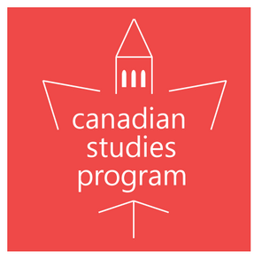
Canadian Election Events
October 2019
Join the UC Berkeley Canadian Studies Program for four events surrounding the 43rd Canadian Election

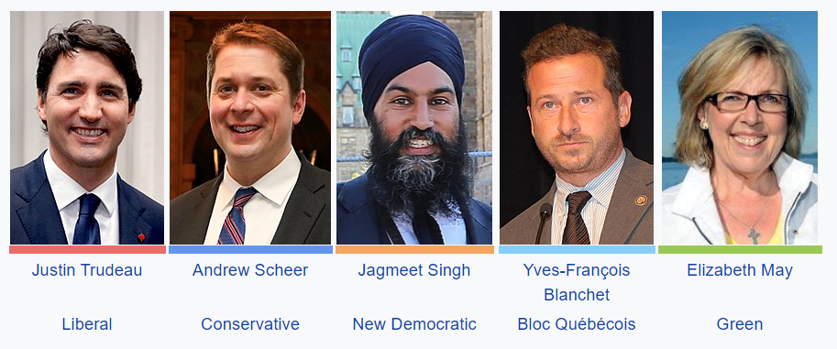

Monday October 7, 4:00 PM, Melodee Cocktails, 240 El Cerrito Plaza, El Cerrito CA
Debate Watch Party: Federal Election English Language Leaders’ Debate
Watch the debate with fans of Canadian politics. Snacks provided, purchase your beverages. Age 21+ only.
RSVP requested: https://canadiandebate.eventbrite.com

Tuesday October 8, 12:30 PM, 223 Moses Hall
Understanding the Federal Election Campaign – Prof. Richard Johnston, Pol. Sci., UBC
Renowned UBC political scientist Richard Johnston will lay out the stakes and issues in 2019 Canadian Federal Election campaign. Lunch provided. Free, open to all. Dr. Johnston’s talk is co-sponsored by the Citrin Center for Public Opinion Research.

Monday October 21, 5:30 PM, 109 Moses Hall (IGS Library)
Canadian Federal Election Results Watch Party
Watch returns from the 43rd General Election in Canada. Refreshments provided. Free, open to all. The watch party is co-sponsored by the Institute of Governmental Studies. RSVP Requested: https://canadianelection.eventbrite.com

Tuesday October 22, 12:30 PM, 223 Moses Hall
Colloquium: Election Post-Mortem – Dr. Eric Guntermann, UC-Berkeley
Voting expert Dr. Eric Gunterman will help us dissect the 2019 elections results. Lunch provided. Free, open to all.

These events are made possible thanks to the generous support
of the Consulate General of Canada San Francisco | Silicon Valley



Twitter.com/BerkeleyCanada Facebook.com/BerkeleyCanada
Canada.Berkeley.Edu

